Please note:
Office use only Date Received:
This form must be signed.
All questions must be answered.
Do not change the question numbers or sequence.
No letter of application, CV or written reference should accompany this form.

Position you are applying for:

1. PERSONAL DETAILS
First Name: |  | Surname:
Home Address: |  | Correspondence Address: (if different)
Home Phone Number: |  | Mobile Phone Number:
Email Address:
No
Are there any restrictions regarding your employment? Yes
(if you answer Yes, please provide details on separate sheet)

Do you require a Work Permit? Yes No

Are you registered with the Teaching Council? Yes No

If YES, Teaching Council Registration Number: __________________

If NO, are you eligible for registration and willing to register? __________________

Please note that the successful candidate will be paid by DES and will have to fulfill DES conditions which include registration with the Teaching Council.

2. PRESENT POSITION
Please give details of your current position:
Employer: | Address: |  | Job Title:
How much notice do you need to give your current employer?

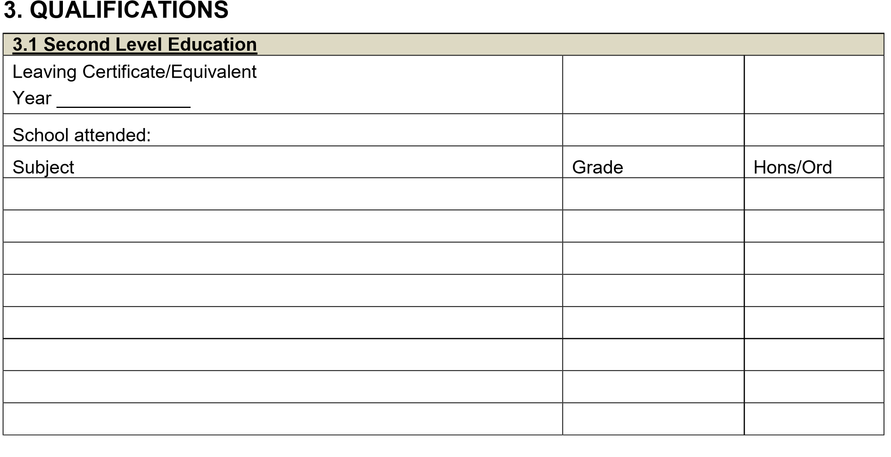
3.2 Primary Degrees/Diplomas:

University/Institute/College:

Qualification (Hons/Pass): | Awarding Body:
Year of Entry: | Year Qualified:
Subjects studied:
First Year Subjects | Final Year Subjects
3.3 PGDE / HDIP / Equivalent):

University/Institute/College:

Qualification: | Awarding Body:
Year of Entry: | Year Qualified:
Subjects studied:

3.4 Post graduate Qualifications

University/Institute/College:

Qualification: | Awarding Body

3.5 In-Service Courses/Training
List any in-service courses/training you have received. Please include dates of the relevant training and duration of these courses. Start with the most recent and work backwards.
Name of Course | Name of Organisation/Institution running course | Length of Course | Year

4. EMPLOYMENT HISTORY

4.1 Teaching Experience
Please provide details of your teaching experience beginning with the most recent post.

Dates  (From/To) | Name & Address  of  School | Contract Type  PWT/RPT/Part-  time | If pro-rata part-time, timetabled hours per week. | Subjects Taught | Level

4.2 Non-Teaching Experience (if applicable)
Please provide details of your work history beginning with the most recent post.

Dates  (From/To) | Name & Address of Employer | Position held | Summary of Main Duties

5. SUPPORTING STATEMENT

This section is for you to provide a summary of your teaching experience, your approach to teaching and any extra-curricular activities you have organised and are willing to promote.

6. REFERENCES
Please provide names, addresses and position/occupation of two people (other than relatives or friends) with knowledge of you and your work to whom professional reference can be made. One should be your current or most recent employer. [Please note: your referees may be contacted without further communication with you and prior to selection interview if shortlisted for interview].

Present or most recent employer:

Name & Title: | Position Held: | Telephone/Mobile: | Email:
Full address:

Other referee:
Name & Title: | Position Held: | Telephone/Mobile: | Email:
Full address:

8. DECLARATION AND SIGNATURE

In the event of you being recommended for this position, the Board of Management is obliged to comply with the terms of current DES circular letters.

If you are recommended for this position, a vetting disclosure must be made available to the Secretary to the Board of Management when the offer of employment is being made. The Board of Management may withdraw an offer of employment if a satisfactory vetting disclosure is not made available.

The Board of Management cannot enter into a Contract of Employment without first receiving a vetting disclosure.

By signing below, you consent to a vetting disclosure, received by the Teaching Council from the Vetting
Bureau, being made available to the school in accordance with the requirements of Circular Letter 31/2016.

You are also required to sign the declaration below certifying that all information you have provided is accurate.
The Selection Committee may wish to check any of the details you have provided.
Providing incorrect information or deliberately concealing any relevant facts may result in disqualification from the selection process or, where discovery is made after an appointment, in summary dismissal.

I declare that the information supplied in this application form is accurate and true.

____________________________________________ ________________________
Signed Date

Completed application forms should be returned by email to vacancies@stlouiscs.com

PLEASE NOTE: If you are awaiting confirmation of registration with the Teaching Council, please insert ‘Pending’ in the Teacher Registration Number section of this Application Form. Any offer of employment will be conditional on registration with the Teaching Council and subject to the satisfactory outcome of the Garda Vetting Process and satisfactory references.

Data Protection – Privacy Notice:
All personal information provided on this Application Form will be processed in a confidential and secure manner as part of the recruitment process. Your data will be retained for a period of 18 months if your application is unsuccessful. If your application is successful, the Board of Management will retain your personal data for the duration of your employment and for 7 years thereafter. Your information will not be disclosed to a third party without your consent save where provided by law or where such processing is necessary to comply with the school’s legal obligations. You may at any time make a request for access to your personal data held by the Board of
Management about you. Should you wish to make any changes or erasures to your personal data, please contact The Board of Management of the school.

