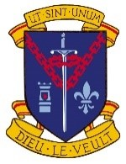 Agreed Report of the Board of Management Meeting
5th July 2023

- The Minutes and Agreed Report for the meeting of 3rd May 2023 were adopted.
- All correspondence was addressed.
- The Child Protection and Anti Bullying reports were presented.
- The four teaching positions and the SNA position were ratified.
- A financial report was provided.
- An update was given on teaching and learning and school developments.
Ms. Mary Mullarkey
Chairperson 21.9.2023

4.

