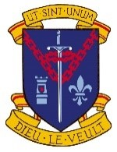 Agreed Report of the Board of Management Meeting
3rd May 2023

Prior to the Board meeting, Mr. Murt Dunleavy, the TY coordinator gave an overview of the TY programme. The coordinator, DPs, TY teachers and SNA’s were complimented for all the work they do with the TY students.

- The Minutes and Agreed Report for the meeting of 22nd February 2023 were adopted.
- All correspondence was addressed.
- The Child Protection and Anti Bullying reports were presented.
- The CCTV policy was ratified.
- A financial report was provided.
- An update was given on teaching and learning and school developments.
Ms. Mary Mullarkey
Chairperson 5.7.2023

4.

