Career Guidance in St. Louis Community School.

‘EDUCATION IS NOT A PREPARATION FOR LIFE, EDUCATION IS LIFE ITSELF’ JOHN DEWEY

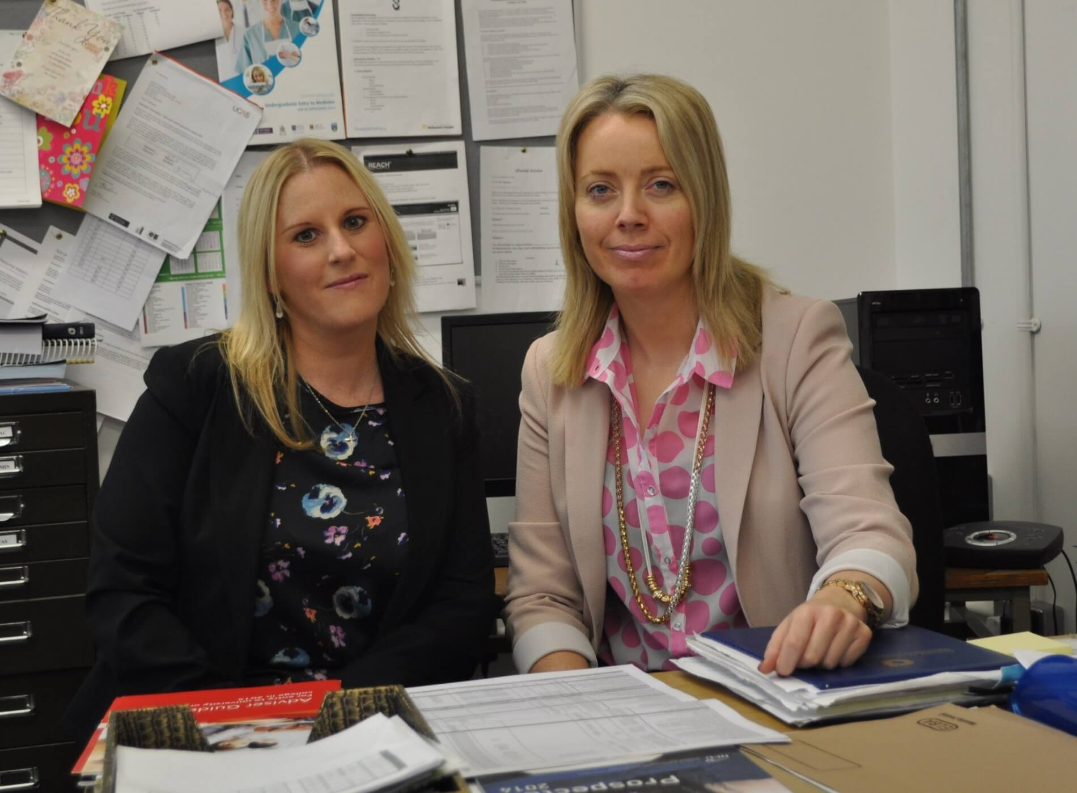

St. Louis CS provides an extensive Career Guidance service to all students to enable them to make informed subject choices and career decisions.

The key areas of delivery are Career Guidance, Educational Guidance and Personal Guidance.
Career Guidance supports students in choosing the right career path.

Educational Guidance equips students with the key foundations to a successful career path. This involves subject choice, study skills and examination preparation. Our philosophy is to be the best student you can.

Personal Guidance enables students to see problems from a different perspective.

We are particularly proud of our Ambassador School Status in the Cycle against Suicide Campaign which promotes positive mental health throughout our school.

